System Software Design Research
Ryan Coon
SDD-610
Professor Adam Hardin
March 4, 2026

Part 1: Research on Architecture Vision
Identify a fictitious scenario where you are asked to solve a business problem and provide a possible architecture vision and solution.
Scenario:
A growing online education company wants to develop a scalable learning management system (LMS) that supports live virtual classrooms, on-demand video courses, interactive quizzes, and personalized learning paths. The business challenge is to create a platform that can handle thousands of concurrent users globally, provide seamless user experiences across web and mobile devices, and allow easy integration with third-party tools like payment gateways and analytics services.
Architecture Vision:
Design a cloud-native, modular, and scalable LMS platform that supports real-time interactions, rich multimedia content delivery, and personalized learning experiences. The system should be highly available, secure, and extensible to accommodate future features such as AI-driven recommendations and gamification.
Solution Overview:
- Frontend - Responsive web application and native mobile apps for iOS and Android, providing intuitive user interfaces for students, instructors, and administrators.
- Backend - Microservices architecture with services for user management, course content delivery, live streaming, quiz management, and analytics.
- Data Layer - Use a combination of relational databases for transactional data and NoSQL databases for storing course content and user activity logs.
- Integration - API Gateway to manage external integrations and internal service communication, message queues for asynchronous processing, and CDN for efficient video streaming.
- Infrastructure - Deploy on a cloud platform with container orchestration (Kubernetes), auto-scaling, and CI/CD pipelines for continuous deployment.
- Security - Implement OAuth 2.0 for authentication, role-based access control, and data encryption in transit and at rest.
Identify possible programming languages, web/mobile frameworks, and development tools that could be used.
Programming Languages
- Backend:
  - Java (with Spring Boot) - for robust, scalable microservices
  - Node.js (JavaScript/TypeScript) - for event-driven, asynchronous services
  - Python (Django or Flask) - for rapid development and AI/analytics integration
- Frontend:
  - JavaScript/TypeScript - core languages for web development
- Mobile:
  - Dart (with Flutter) - for cross-platform mobile app development
  - Swift (iOS native) and Kotlin (Android native) - for platform-specific apps if needed
Web/Mobile Frameworks
- Web Frontend:
  - React.js or Angular - for building responsive, component-based web applications
- Mobile Apps:
  - Flutter - for building performant cross-platform apps with a single codebase
  - React Native - alternative for cross-platform mobile development
- Backend Frameworks:
  - Spring Boot (Java) - for building microservices with strong ecosystem support
  - Express.js (Node.js) - lightweight framework for RESTful APIs
  - Django (Python) - for rapid backend development and integration with AI modules
Development Tools
- Containerization and Orchestration:
  - Docker for containerizing services
  - Kubernetes for orchestration and scaling
- CI/CD Pipelines:
  - Jenkins, GitLab CI/CD, or GitHub Actions for automated testing and deployment
- Version Control:
  - Git with platforms like GitHub, GitLab, or Bitbucket
- Monitoring and Logging:
  - Prometheus and Grafana for monitoring
  - ELK Stack for logging and analysis
- API Management:
  - Kong or AWS API Gateway for managing and securing APIs
- Real-time Communication:
  - WebRTC or Socket.IO for live virtual classroom streaming and interaction
- Content Delivery:
  - CDN services like Cloudflare or AWS CloudFront for efficient video streaming
Draw block diagrams that supports your conceptual, logical, and physical views in the system solution design.

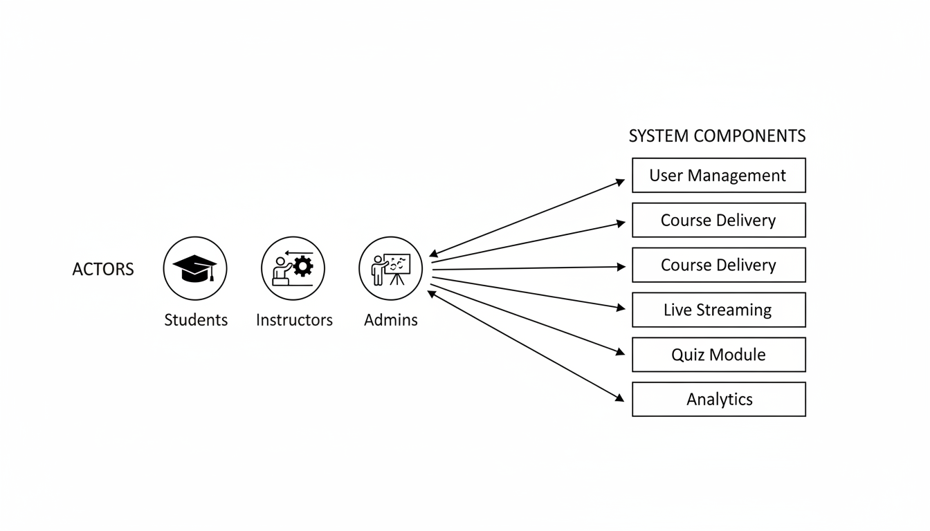
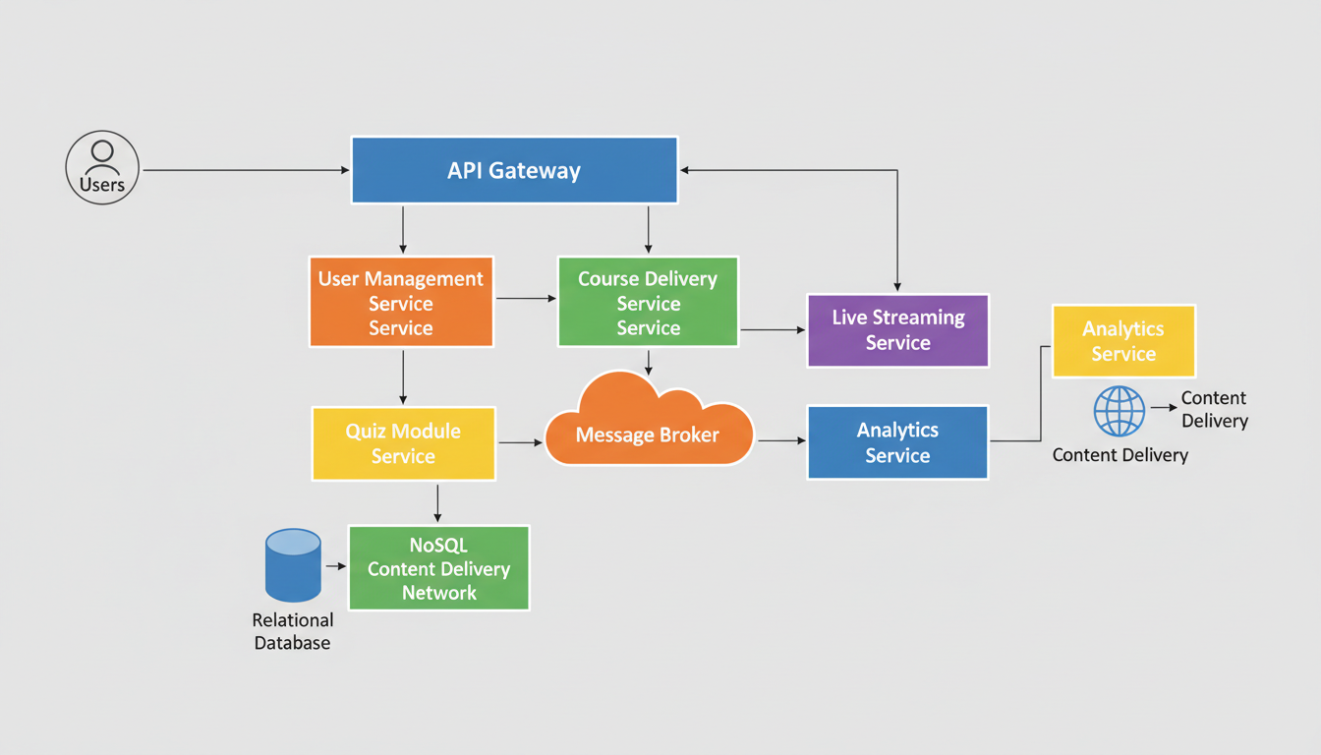
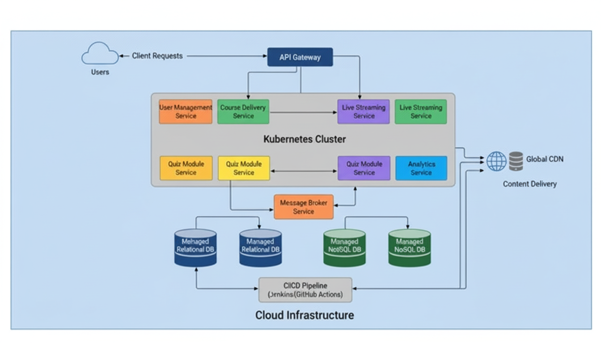
Identify 5 design patterns that could be applied to the system solution design
1. Microservices Pattern
Narrative:
The LMS is decomposed into loosely coupled, independently deployable services such as User Management, Course Delivery, Live Streaming, Quiz Module, and Analytics. This pattern supports scalability, fault isolation, and independent development.
2. Observer Pattern
Narrative:
Used for event-driven communication between services. For example, when a student completes a quiz, the Quiz Module publishes an event that the Analytics Service subscribes to for updating user progress and generating reports.
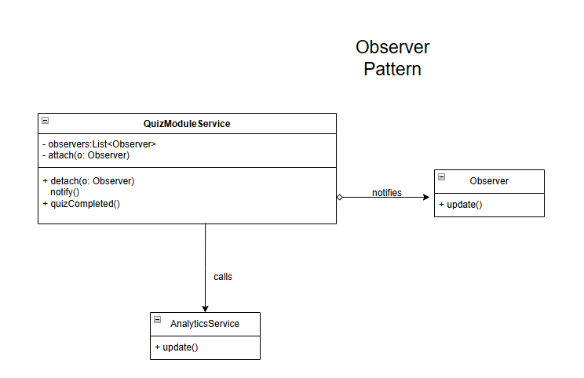
3. Facade Pattern
Narrative:
The API Gateway acts as a facade, providing a simplified and unified interface to the clients, web and mobile apps, while internally routing requests to multiple microservices. This hides the complexity of the underlying system from clients.
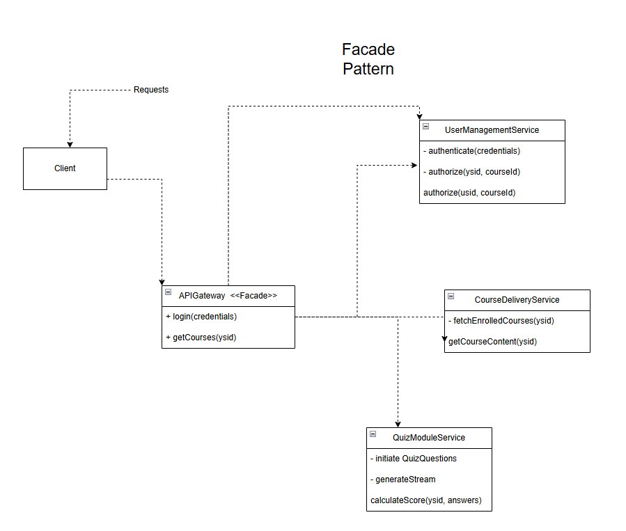
4. Strategy Pattern
Narrative:
The Quiz Module can support multiple grading strategies such as automatic grading, manual grading, peer review. The Strategy pattern allows selecting and switching grading algorithms at runtime without changing the module’s core logic.
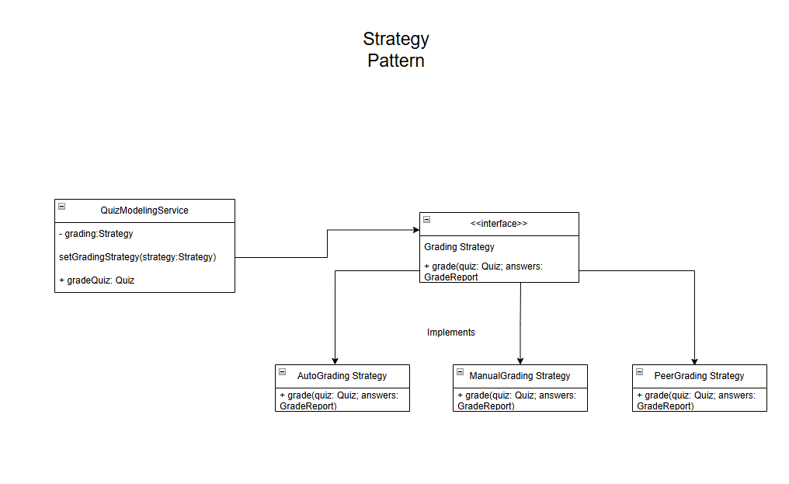
5. Decorator Pattern
Narrative:
Additional features like logging, authentication, or caching can be dynamically added to service requests without modifying the core service logic. For example, the Course Delivery Service can be decorated with caching to improve performance.
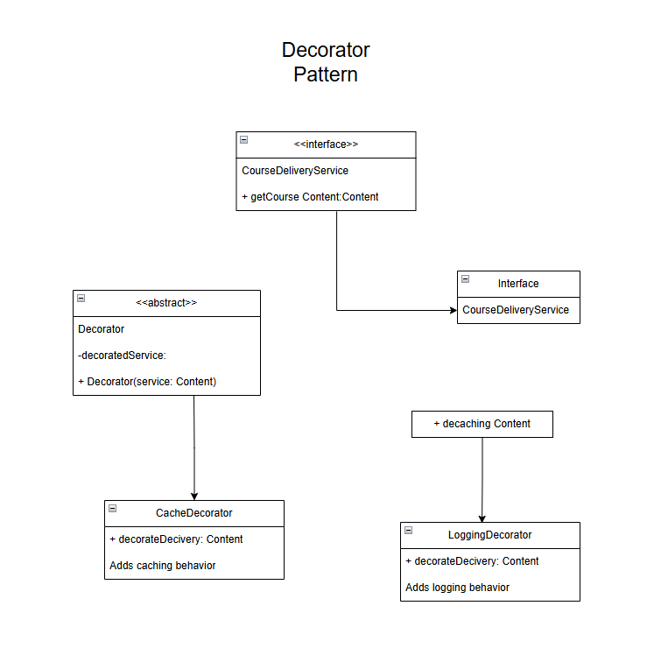
Provide a narrative for how 5 SOLID principles would be supported in the system solution design
1. Single Responsibility Principle (SRP)
Each module or microservice in the LMS architecture is designed to have one and only one responsibility. For example, the User Management Service handles all user-related operations such as authentication, authorization, and profile management, while the Course Delivery Service is solely responsible for managing course content and delivery. This separation ensures that changes in one service such as updating user roles, do not affect unrelated services, making the system easier to maintain and evolve.
2. Open/Closed Principle (OCP)
The LMS design allows services and components to be open for extension but closed for modification. For instance, the Quiz Module Service uses the Strategy pattern to support multiple grading strategies automatic, manual, peer review. New grading strategies can be added by implementing the GradingStrategy interface without modifying existing code. This approach promotes flexibility and reduces the risk of introducing bugs when extending functionality.
3. Liskov Substitution Principle (LSP)
In the LMS, any subclass or implementation of an interface can be substituted without affecting the correctness of the system. For example, different grading strategies AutoGradingStrategy, ManualGradingStrategy, PeerReviewStrategy, implement the same GradingStrategy interface and can be used interchangeably by the Quiz Module. This ensures that components relying on the interface do not need to know the concrete implementation details, supporting polymorphism and robustness.
4. Interface Segregation Principle (ISP)
The LMS services expose focused, client-specific interfaces rather than large, monolithic ones. For example, the API Gateway provides tailored endpoints for different clients (web, mobile, admin) without forcing them to depend on unused methods. Similarly, microservices expose only the necessary APIs relevant to their domain, preventing clients from being burdened with irrelevant functionality and reducing coupling.
5. Dependency Inversion Principle (DIP)
High-level modules in the LMS depend on abstractions rather than concrete implementations. For example, the Quiz Module depends on the GradingStrategy interface rather than specific grading classes. This allows the system to inject different grading strategies at runtime, facilitating testing, maintenance, and flexibility. Similarly, the API Gateway depends on service interfaces, enabling easy replacement or upgrading of backend services without impacting the gateway logic.
Part 2: Research Question from the Textbook
What kinds of business goals have driven the construction for the following?
- The World Wide Web
The construction of the World Wide Web was driven by the business goal of creating a universal, accessible platform to facilitate global information sharing and communication. Tim Berners-Lee designed the Web to enable instant promotion and exchange of information, which opened vast opportunities for e-commerce, digital marketing, remote work, and data analytics. The Web aimed to democratize access to information and support businesses in reaching global markets efficiently, transforming how companies communicate and operate worldwide.
- Amazon’s EC2 cloud infrastructure
In contrast, Amazon’s EC2 cloud infrastructure was developed with the goal of providing scalable, flexible, and cost-effective computing resources on demand. EC2 allows businesses to dynamically resize their computing capacity, reducing upfront hardware costs and enabling rapid innovation and operational agility. This infrastructure supports digital transformation by making powerful, secure cloud computing accessible to organizations of all sizes, helping them optimize costs and accelerate growth.
References:
Amazon Web Services. (n.d.). AWS Executive Insights | Cloud Strategy. Amazon Web Services, Inc. https://aws.amazon.com/executive-insights/cloud-strategy/
apollodisplays. (2023, August 3). The Impact of the World Wide Web on Business and Commerce. Fortec US. https://fortec.us/the-impact-of-the-world-wide-web-on-business-and-commerce/
DoiT International. (2024, October 22). AWS EC2: Costs, Benefits, Features, and Best Practices | DoiT. DoiT. https://www.doit.com/blog/aws-ec2-costs-benefits-features-and-best-practices/
Kadam, A. (2023, June 6). Futran Solutions Inc. Futran Solutions. https://futransolutions.com/blog/why-amazon-ec2-is-the-future-of-business-operations/
World Wide Web Foundation. (2018). Our Impact. World Wide Web Foundation. https://webfoundation.org/impact/

